

**The Middlesex County Chapter**

***Membership Report***

***Happy Friendship Month***

***November 14, 2020***

**November Core Value:**

**LEGACY-** Our rich history creates the foundation for our evolving organization. Through the celebration of history, we honor and pay respect to our Founders, the first “Links Club,” the pioneers and visionaries for our organization.

**SERVICE -**Service is the time, effort and resources expended by the members of The Links, Incorporated to develop and implement innovative programs designed to meet the ongoing challenges faced by the communities we serve. We are committed to the performance of service because service is the very heart of Linkdom.

**Friendship Month Activities: Arnold Arboretum**

Since the weather was warm last weekend, we decided to kick off our Friendship Month activities with a Friendship Stroll which was held on Sunday, November 8th at the Arnold Arboretum. Link Kimmie decorated masks for the group to wear as we strolled through the Arboretum.

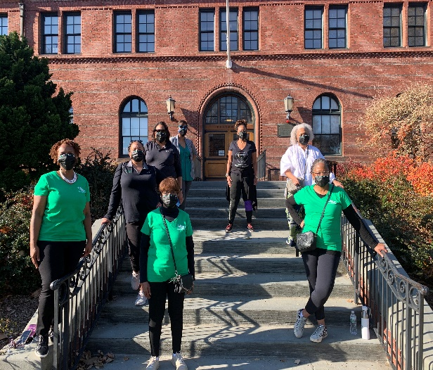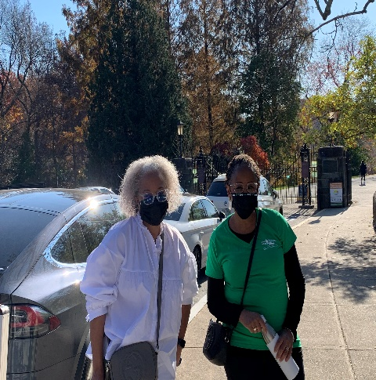

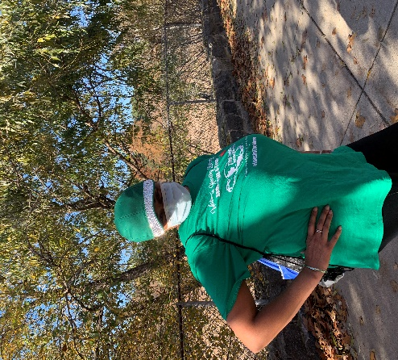

**Afro Flow Yoga:**

On Sunday, November 15th at 1:30pm we ask you to join us for an Afro Flow Yoga Class. This class is offered by Leslie Salmon Jones and her husband Jeff Jones.

The link to register is: [**https://www.afroflowyoga.com/events/categories/classes/online-classes-classes/**](https://www.afroflowyoga.com/events/categories/classes/online-classes-classes/) **.** They have a recorded class on their YouTube channel that was done in May of this year. It will give you an idea of what a 60-minute flow looks like [**https://youtu.be/GnPrcbnGIRo**](https://youtu.be/GnPrcbnGIRo)

**Eastern Area Updates:**

Please join the Eastern Area in commemorating 74 years of “Friendship & Faith” on November 15 at an area-wide Virtual celebration of Founders Day. (Registration email sent on October 26)

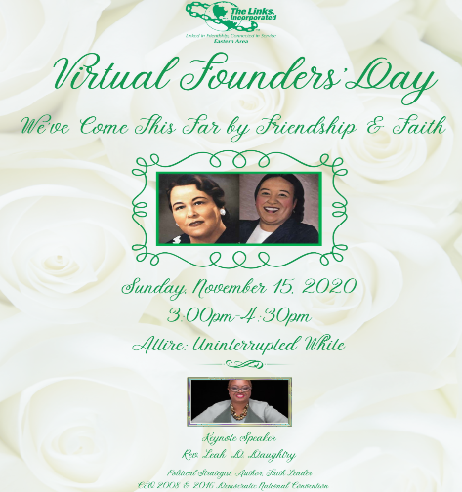

**Important Dates/Deadline:**

Transfer Period – May 1st to November 30th

Reinstatement- September 1st – December 1st

**Area Updates/Reminder:**

Eastern Area Conference-April 14-18, 2021, Philadelphia, PA

Sisterly Submitted,

Liz Clark Donald

Link Liz Clark Donald